A000-Afr-Nigeria-Yoruba Divination Tray-Face Figures-mid 20th c

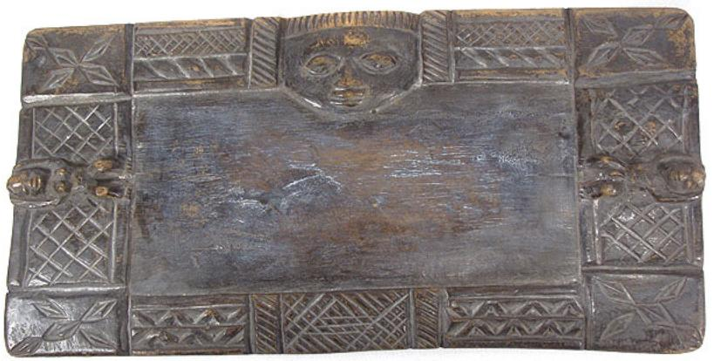 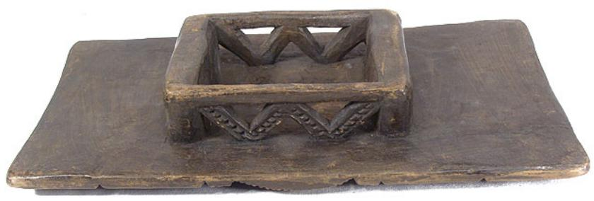

Case No.: 6

**Accession No.**

**Formal Label:**

**Display Description:**

Ifá refers to the system of [divination](http://en.wikipedia.org/wiki/Divination) and the verses of the literary corpus known as the Odú Ifá. [Yoruba religion](http://en.wikipedia.org/wiki/Yoruba_religion) identifies [Orunmila](http://en.wikipedia.org/wiki/Orunmila) as the Grand Priest; as that which revealed Oracle divinity to the world. Such is his association with the Oracle divinity; in some instances, the term "Orunmila" is used interchangeably with Ifá (Bascomb 1969).

Originating in [West Africa](http://en.wikipedia.org/wiki/West_Africa) in the form of a stringent [Yoruba](http://en.wikipedia.org/wiki/Yoruba_people) philosophy; celebrated in [traditional African medicine](http://en.wikipedia.org/wiki/Traditional_African_medicine), [Santería](http://en.wikipedia.org/wiki/Santería) (referred to as [Lukumi](http://en.wikipedia.org/wiki/Lucumi_religion)), [Candomblé](http://en.wikipedia.org/wiki/Candomblé), West African & Diaspora [Vodou](http://en.wikipedia.org/wiki/West_African_Vodun), and similarly in [Orisa](http://en.wikipedia.org/wiki/Orisa)'Ifa lineages all over the globe.

Performing Ifa divination is called Ifa dida or idafa (ounte ale) ([Ṣọlágbadé Pópóọlá Library](http://www.worldcat.org/search?q=au%3AṢọlágbadé+Pópóọlá+Library.&qt=hot_author) 2008) Ifa dida / Idafa is performed by a Babalawo or Iyalawo or iyanifa (an initiated priest or priestess). Babalawo can be translated as "father of the secrets" while "Iyalawo" {mother of secret} or sometimes "Iyanifa" means "mother that has Ifa(i.e. its blessing)". The babalawo or iyanifa provides insights about the current circumstances impacting the life of a person requesting this information and provides any necessary information to aid the individual. Awo is a reference for devotees in Orisa worship. It includes Babalawos, Iyalawo, Iyanifas, Babalorishas, Iyalorishas and even uninitiated devotees. Traditionally, women have not been initiated into Ifa priesthood, according to the teaching which allows them only a single Ikin. In the USA a small sect of worshipers has initiated women into Ifa. These initiations are however only recognized by that group.

**LC Classification:**

**Date or Time Horizon:**

**Geographical Area:**

**Map:**

**GPS coordinates:**

**Cultural Affiliation:**

**Media: wood, kaolin**

**Dimensions:** 13.5 inches L. x 6.75 inches W. x 2.25 inches H

**Weight:**

**Condition:**

**Provenance:**

**Discussion:**

Ifa divination (also called consultation) is performed for many proposes and a host of occasions, the purposes and occasions is what determines the instrument used in the divination sessions. Divination is often performed for lesser reasons such as "regular check up" to life-changing occasions such as marriage or child birthing etc., divination can also be performed for a group (small / large) or community (the first examples are more likely for a person, couple, parents or family). On occasion when it is performed for the community or society it takes on another significance. Below we will list and discuss major occasions divination is performed and give some feedback and examples of each, in application and practice.

* Annual Divination for the New Year - one occasion where a major divination is performed and the ranking Ifa Priest are present to witness and partake. This is called the divination of the new year, which is also sometimes referred to as the First Yam Festival (for ancient annual agricultural cycles). For the current year 2012 / 2013 (the Yoruba year begins early June for a 12 month cycle), is the holy Odu Ifa Ogbe Ogunda (alias Ogbe Iyonu/ OgbeYonu / OgbeYono and Ogbe Suuru etc. each alias has special meaning). The results of such a divination will be discussed and analyzed by the ranking Ifa Priest, shared with the Ooni (the ruling King of Yoruba People), and shared with the extended community.
* Establishing a new town or settlement, is another reason Ifa is cast to know more about that towns living principals and parameters etc. An example can be found in IrosunMeji.
* Mate selection - (or courting) a potential partner, several examples will be posted shortly.
* Esentaye (new born baby rites) - Also called Ikosedaye, is another major occasion to consult Ifa for direction and advice
* Burial rites
* Planning a new business or enterprise etc.

Initiation into Ifa requires rigorous study. A Babalawo must learn and understand each of the 256 chapters (Odu) of Ifa. The minimum of four verses will of necessity include ebos and ooguns (medicine) that are embedded and relevant to each of the verses, plus other issues that complement divination. An accomplished Babalawo must know about ten verses of each of the 256 chapters of Ifa (256 Odu Ifa). Regardless of gender, whoever aspires to practice Ifa must have this qualification. In essence, Ifa practice does not preclude a woman provided such woman acquires the required qualification. Odu — a special Orisa — can only be received by a Babalawo who decides to perform the special initiation that will allow him access to Odu. In essence, initiation into Ifa is the first step towards initiation into Odu. A woman cannot be initiated into Odu. This is because since she already has a womb, she has no need to receive Odu. It can be said to be redundant. Character Traits of an Awo: Orunmila demands humility from his priests and priestesses, therefore, a Babalawo should be an embodiment of patience, good character, honesty, and humility.

**References:**

Bascom, William. 1969 Ifa Divination: Communication Between Gods and Men in West Africa. Bloomington, Indiana: Indiana University Press.

[Ṣọlágbadé Pópóọlá Library.](http://www.worldcat.org/search?q=au%3AṢọlágbadé+Pópóọlá+Library.&qt=hot_author) 2008. [Ifá Didá : an Invitation to Ifá divination](http://www.worldcat.org/title/ifa-dida-an-invitation-to-ifa-divination/oclc/665179779&referer=brief_results) Lagos : Aṣèfín Media